**IMPORTANT UNDERSTANDING OF EXPERIMENT 1**

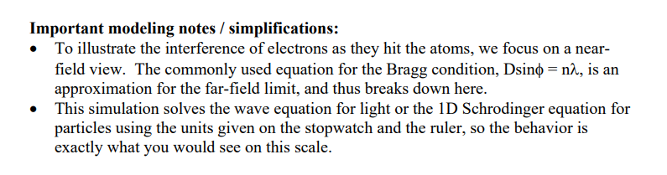

**Davidson Germer Experiment:**

The experimental arrangement of the Davisson Germer experiment is discussed below:

* An electron gun comprising a tungsten filament F was coated with barium oxide and heated through a low voltage power supply.
* While applying suitable potential difference from a high voltage power supply, the electron gun emits electrons which were again accelerated to a particular velocity.
* In a cylinder perforated with fine holes along its axis, these emitted electrons were made to pass through it, thus producing a fine collimated beam.
* The beam produced from the cylinder is again made to fall on the surface of a nickel crystal. Due to this, the electrons scatter in various directions.
* The beam of electrons produced has a certain amount of intensity which is measured by the electron detector and after it is connected to a sensitive galvanometer (to record the current), it is then moved on a circular scale.
* By moving the detector on the circular scale at different positions that is changing the θ (angle between the incident and the scattered electron beams), the intensity of the scattered electron beam is measured for different values of angle of scattering.

The Davidson-Germer experiment is a classic experiment in physics that demonstrated the wave-like nature of electrons. It involved scattering electrons off of a nickel crystal and observing the diffraction pattern produced.

To verify the Davidson-Germer experiment practically, you would need to set up a similar experiment in a laboratory. Here are the basic steps:

Prepare a nickel crystal. The crystal should be free of impurities and defects.

Set up an electron gun. The electron gun should produce a beam of electrons with a consistent energy and wavelength.

Direct the electron beam onto the nickel crystal at a specific angle. The angle should be chosen to produce diffraction of the electrons.

Place a detector on the other side of the nickel crystal. The detector should be able to detect the scattered electrons and record their positions.

* Target: The target is a Nickel crystal. The electron beam is fired normally on the Nickel crystal. The crystal is placed such that it can be rotated about a fixed axis.
* Detector: A detector is used to capture the scattered electrons from the Ni crystal. The detector can be moved in a semicircular arc as shown in the diagram above.

Observations of Davisson Germer experiment:

From this experiment, we can derive the below observations:

* We obtained the variation of the intensity (I) of the scattered electrons by changing the angle of scattering, θ.
* By changing the accelerating potential difference, the accelerated voltage was varied from 44V to 68 V.
* With the intensity (I) of the scattered electron for an accelerating voltage of 54V at a scattering angle θ = 50º, we could see a strong peak in the intensity.
* This peak was the result of constructive interference of the electrons scattered from different layers of the regularly spaced atoms of the crystals.
* With the help of electron diffraction, the wavelength of matter waves was calculated to be 0.165 nm.

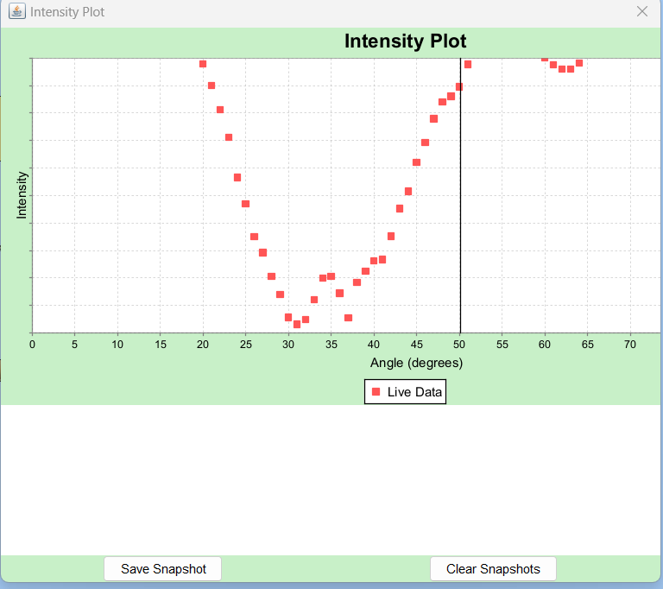

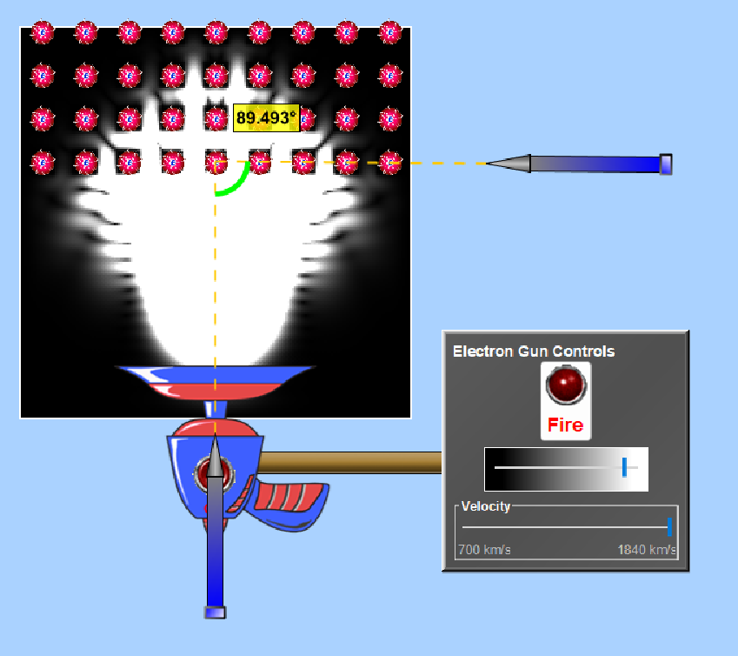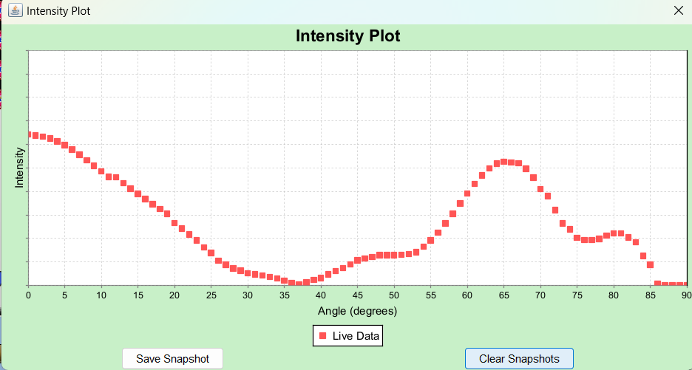

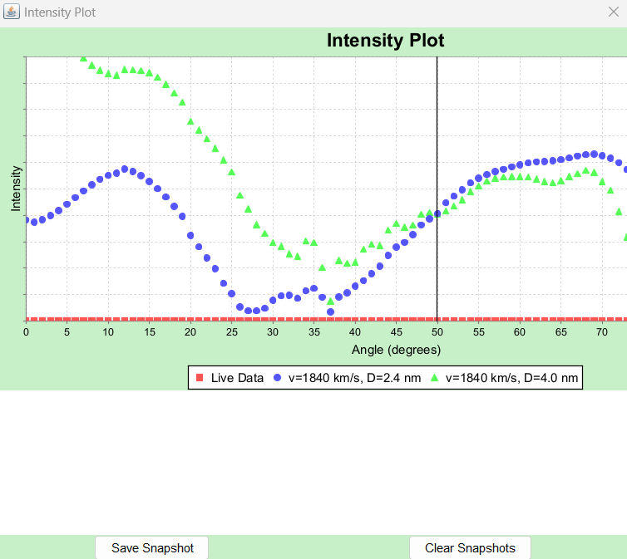

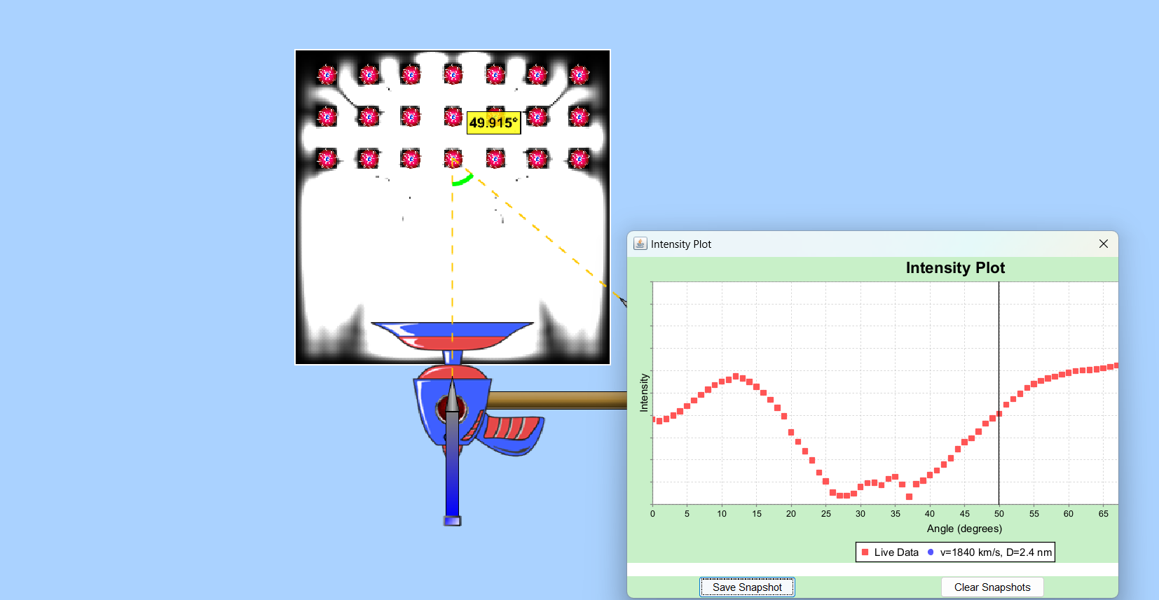

CALCULATIONS:

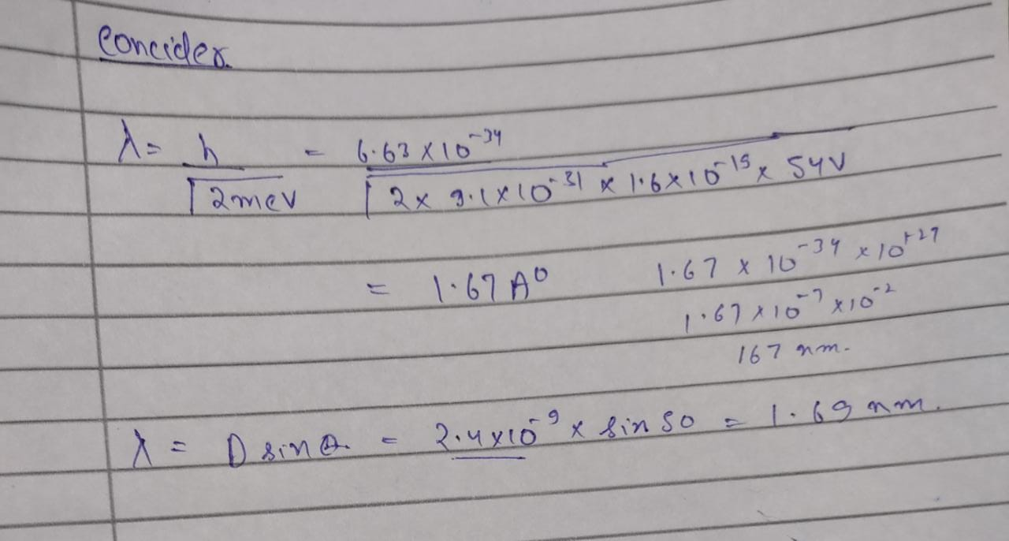

**Analysis Of Experiment 2:**

**Problem Description:**  
This experiment generates a simulated light spectrum of hydrogen. You must run this at least 5 minutes and take a snapshot of your experimental results. You will then look at spectra predicted by different models of the atom. You will test Dalton's Billiard Ball model, Classical Solar System Model, Bohr's Model of Hydrogen and Schrodinger's Model.

You will examine the different models of hydrogen atom, consider the emission spectrum generated and compare it to the YOUR experimental emission spectra above. You will use a snapshot you took of the experimental spectrum wavelength for this comparison.

**Introduction:**  
  
When light from the Sun or white light is passed through a prism it produces a "rainbow" of different colors. This has been known for centuries, with Isaac Newton making significant advances in the area of "Opticks" in the 1700's by investigating how light is reflected, refracted, dispersed, etc.

However, something very different occurs when a photon of light from a single element is emitted and passed through a prism. In this case only a small number of discrete lines are observed.

Even more remarkably, the pattern of these lines is a defining characteristic of each element. Here are the atomic spectra of mercury and strontium as examples. Each has its own discreet lines at particular wavelengths. The lines represent the photon of energy that is emitted from the atom.

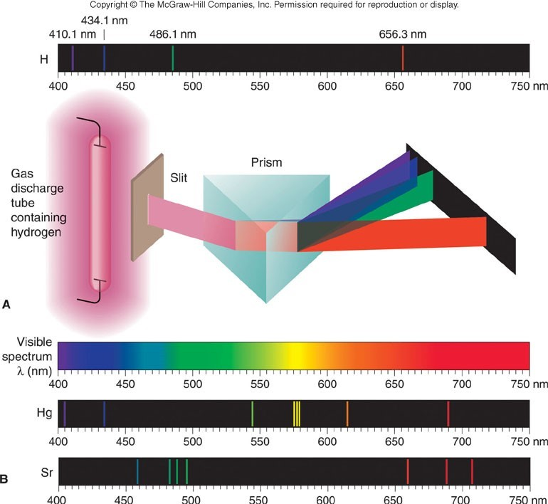

What happens when light is emitted from an element like hydrogen? As you will see in this investigation, the answering of this question has led to profound insights into the electronic structure of the atom and, in turn, our modern understanding of chemistry.

The emission of photons (particles of light) from atoms is thought to occur in the following way: First, the atom absorbs energy and an electron moves to a higher energy level, or "excited state." When the electron eventually returns to a lower energy state, energy is released. The specific amount of energy released corresponds to the difference between the energy levels. When this energy difference corresponds to visible light then our eyes can observe color. It is also possible the emitted photons will have energies we cannot see, such as in the infrared or ultraviolet regions of the electromagnetic spectrum.

Atoms can absorb energy in various forms (heat, electrical, radiant) and subsequently emit photons. Today, in this investigation, you will complete activities that involve radiant energy (photons of light). The atoms absorb and emit photons of energy. We use the emission spectrum to identify changes in energy.

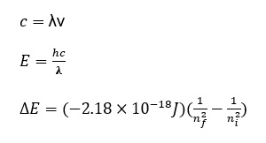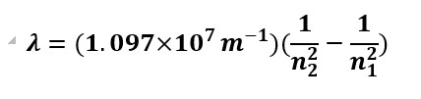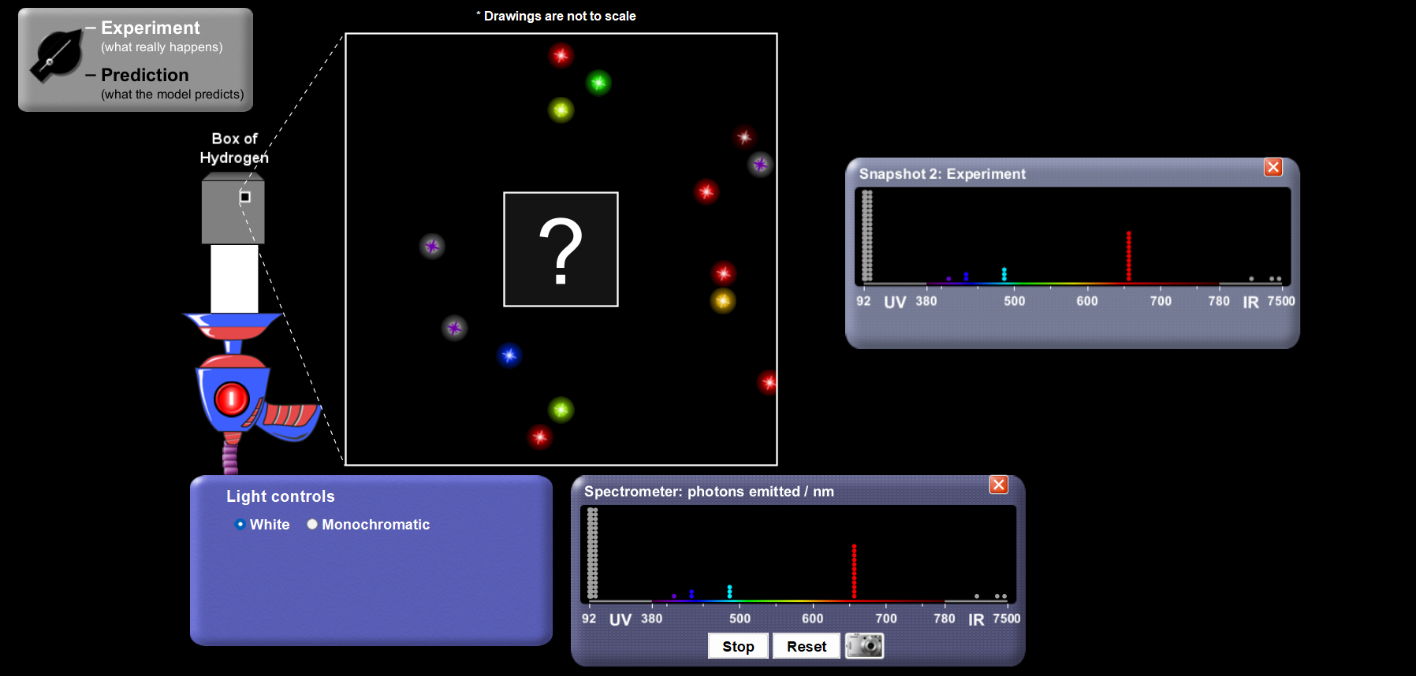**Question 1:**  
  
From the emission spectrum generated in the experiment (the "?-box"), briefly identify:

1. the colors; and
2. the approximate wavelengths of the H atomic spectrum in your "?-box." (The relative amount of the light (stacked boxes) is generally related to how long you run the experiment.)

**Questions 2 - 4:**

1. If a photon of monochromatic light has a wavelength of 94 nm, what is its frequency per second or Hz, s-1?
2. What is the energy (J) of one photon?
3. What is the energy of one mol of photons at 94 nm?

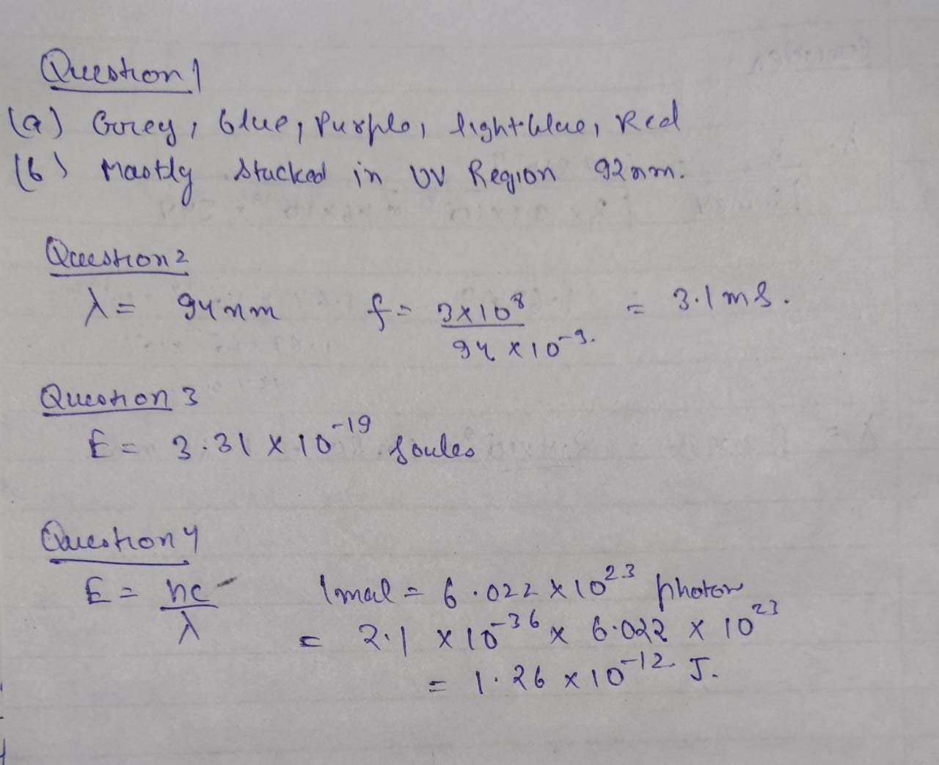

**Use Dalton's Billiard Ball Model:**  
  
A brilliant model which is still useful but which was also wrong about an atom being non-divisible (smallest particle). However, it is still true that the atom is unique. I think the idea that the atom is the smallest particle that 'retains all the characteristics of that element' is still true. We now know that an atom consists of many smaller particles. In this class, we study the electrons, principally. "Valence Electrons" are the particles involved in chemical reactions.

Take a couple of minutes to look at the "Billiard Ball" model.

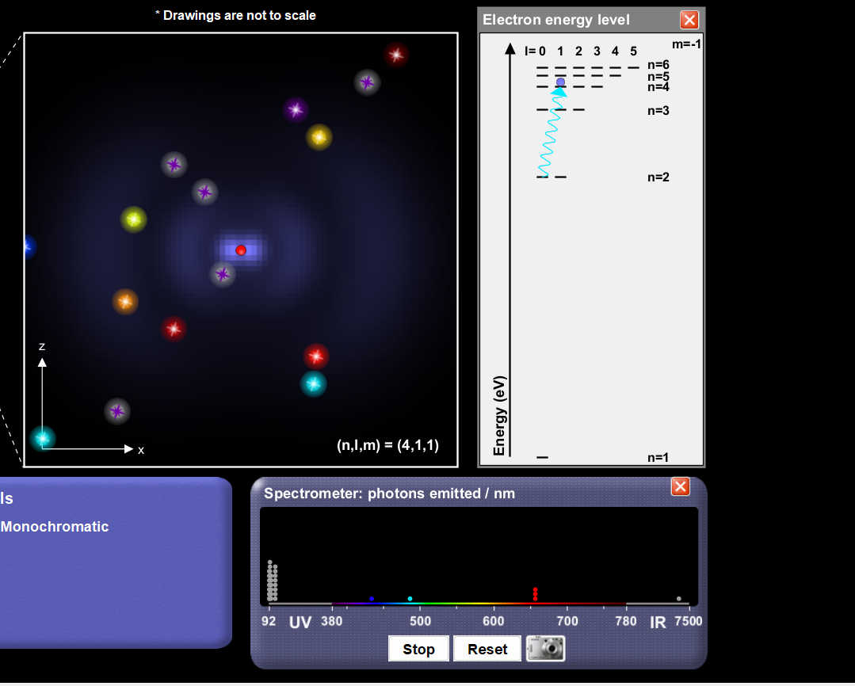

**QnA:**

Briefly speculate why the electron loses energy and spirals into the nucleus. **Comment:**What does this mean to our model? It means that the electron must have its own 'ground-state' energy that resists/prevents the destruction of the atom.

Ans: This Could be one of the drawbacks of Dalton billard ball model because the electron revolve around nucleus with the integral multiple of nh/4pi. This problem was solved by bohr model.

**Results:**

**Here we can see clearly in our spectometre that there is more number of uv photon emitted and then the red photons in range 650-700nm respectively.**

**Use Bohr Model:**  
  
Switch to the Bohr Model and Run this simulation on fast for at least 5 minutes to compare to your snapshot of the experimental electromagnetic spectrum. Be sure to take a snapshot for later comparison to experimental results.

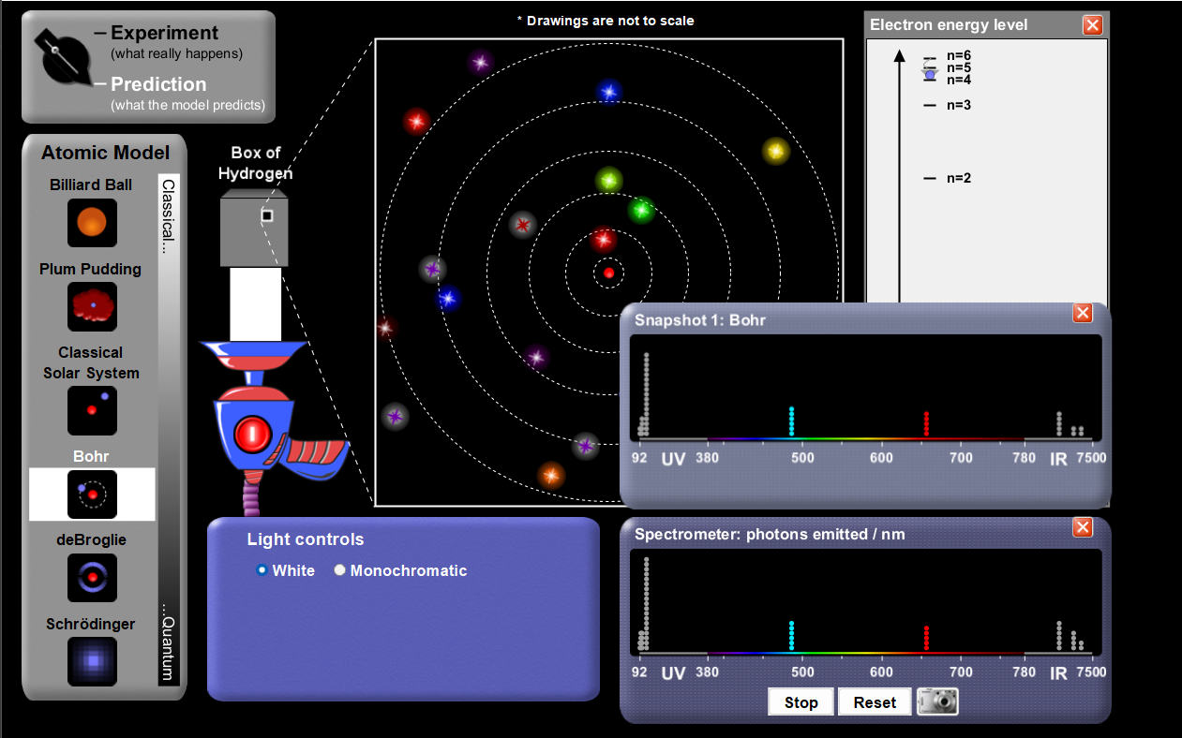

**Observations:  
We can clearly see that the electron collides with the photons and excited to higher energy states and we can see maximum emmited electron in UV region I.E 92-380nm respectively.**

**Use Schrodinger's Model:**  
  
You may need to run this simulation on fast for more than 5 minutes.

This is a more sophisticated model than Bohr's. When an electron interacts with the atom, the simulation shows the 'shape' of the orbital cloud. We have seen these as quantum numbers.

* When l = 0 (or s), the shape is a sphere;
* When l = 1 (or p), the shape is similar to a barbell.
* When l = 2 (or d) the shape is similar to a cloverleaf.

Notice that the shape is larger when the 'n' is larger.

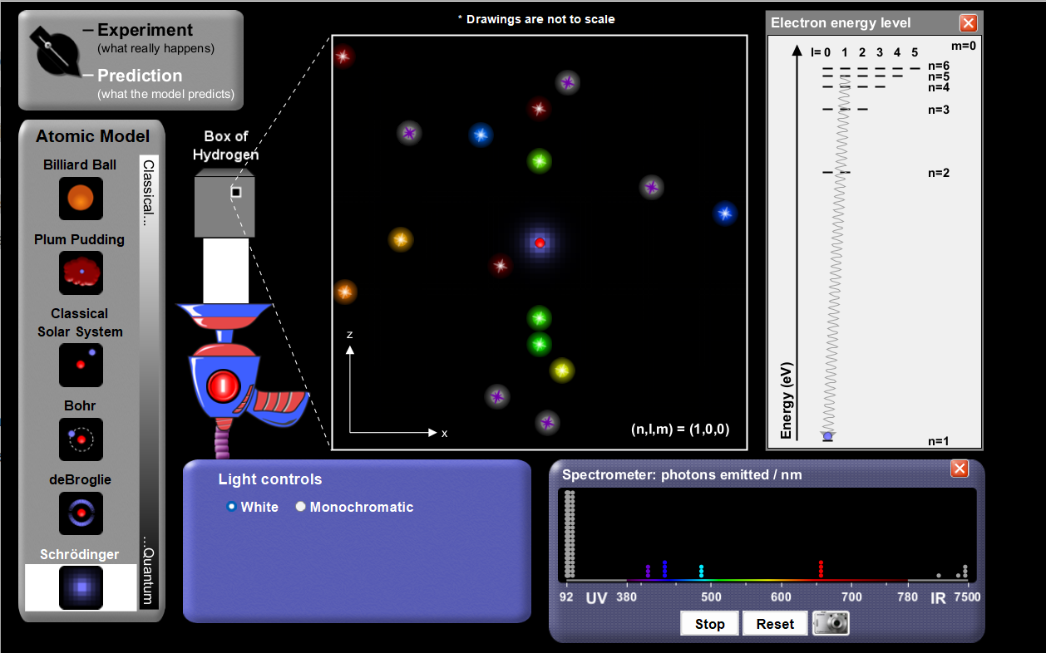

**EXPERIMENT 3**

**QUANTUM TUNNELING**

Tunneling is a qu

antum mechanical phenomenon when a particle is able to penetrate through a potential energy barrier that is higher in energy than the particle’s kinetic energy. This amazing property of microscopic particles play important roles in explaining several physical phenomena including radioactive decay. Additionally, the principle of tunneling leads to the development of Scanning Tunneling Microscope (STM) which had a profound impact on chemical, biological and material science research.



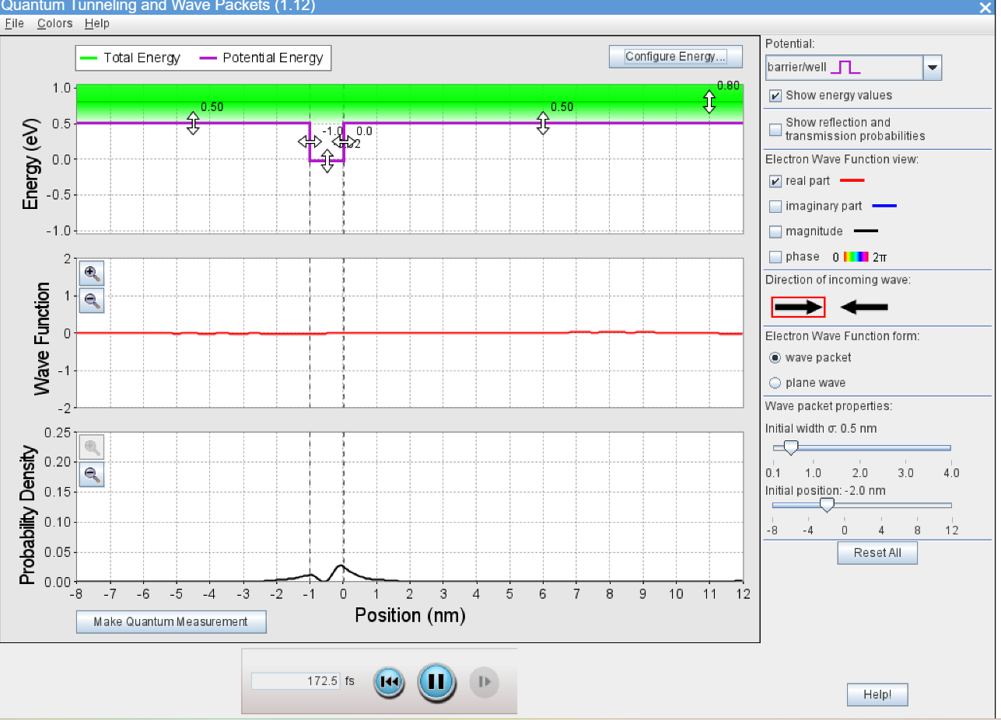

**Observation: we can clearly see that the probability of electron in mid is almost equal to zero and also we can see the QM phenomenon as we can see the electron density near the barrier.**

**Analysis 2  
Both walls has same finite potential:**